
Backlink Profile Audit Report
https://www.zavior.org/

Backlink Profile Analysis:
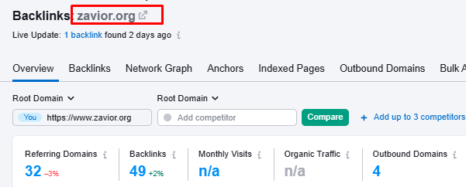
Total Backlinks: 49
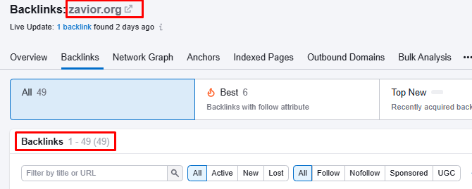

Referring Domain Analysis: 32
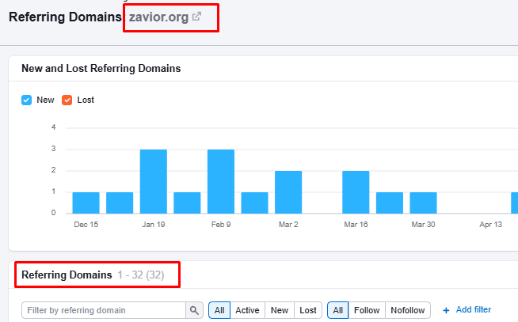

Referring IP Analysis: 11
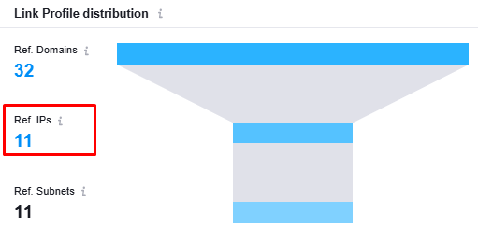

Backlink Indexing Ratio Analysis:
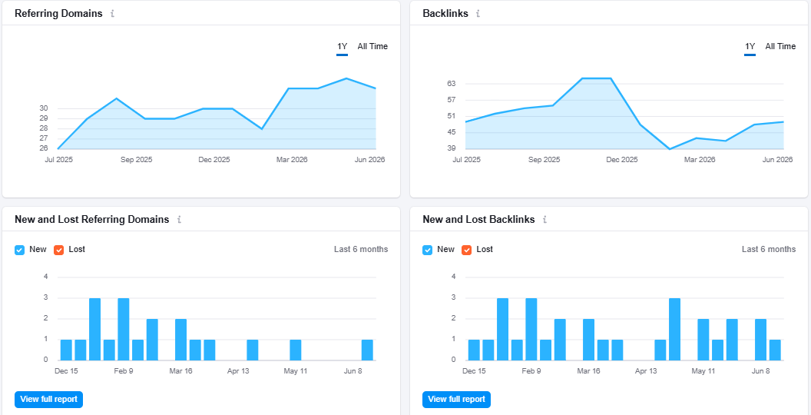

Network Graph:
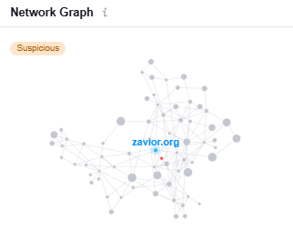

Authority Analysis:
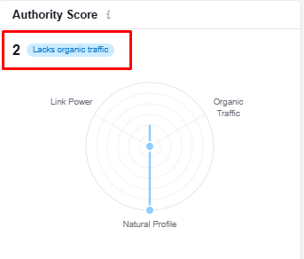

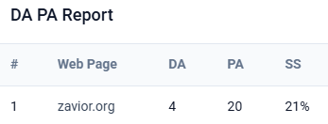
Observation:
- DA: 4
- PA: 20
- Spam Score: 21%
- DA and PA need to be improved to
of increasing website authority.

Thank You

